### ***Depression: A Common Mental Disorder***

Project Report

# INTRODUCTION

* 1. **Project Overview**

In this project we are trying to analyze the depression data for different countries and extract some insights from the data using Data Analytics tools. To Extract the Insights from the data and put the data in the form of visualizations, Dashboards and Story we employed Tableau tool.

* 1. **Purpose**

The purpose of a data analysis project on depression, a common mental disorder, is to gain insights into its prevalence, causes, and impact on individuals and society. By analyzing data, we can identify patterns, risk factors, and trends, which can inform effective prevention, treatment, and support strategies, ultimately contributing to improved mental health and well-being.

# LITERATURE SURVEY

* 1. **Existing problem**   
     Depression is a common and debilitating mental disorder that often goes undiagnosed and untreated due to stigma, lack of awareness, and disparities in access to mental health services. The social stigma attached to depression can discourage individuals from seeking help, leading to isolation and worsening symptoms. Depression often co-occurs with other mental health disorders, making diagnosis and treatment more complex. Developing and implementing effective prevention strategies to reduce the onset of depression remains an important challenge.

* 1. **Problem Statement Definition**

Mental health is a global concern with far-reaching effects. Our project uses data to better understand this issue on a global scale. We collect diverse data from sources like hospitals, research, and health agencies to uncover the factors behind mental health challenges. We'll look at the prevalence of different mental health problems, where they're most common, and how things like income, culture, and the environment affect mental health. This data will help create policies and strategies to support people's well-being worldwide. We'll keep in mind that data might not be perfect and will handle it ethically. Our goal is to improve our understanding of mental health and create a more caring global response to this important issue.

# IDEATION & PROPOSED SOLUTION

* 1. **Empathy Map Canvas**
* Define the persona: Start by identifying the target audience or persona you want to understand better. This could be a customer, user, or any specific group of people.
* Gather data: Collect information about the persona's characteristics, needs, behaviors, and emotions. Use surveys, interviews, observations, and any available data sources.
* Create the empathy map template: Draw a simple diagram or use a pre-designed template that represents the persona. Divide it into four quadrants: "Seeing," "Thinking and Feeling," "Hearing," and "Doing."
* Fill in the quadrants: Based on the gathered data, populate each quadrant with relevant insights and details that provide a deeper understanding of what the persona sees, thinks and feels, hears, and does.
  1. **Ideation & Brainstorming**

Ideation: Ideation is the process of generating a wide range of ideas, typically without initially evaluating or critiquing them. The goal is to encourage creativity and free thinking to explore various possibilities.

Brainstorming: Brainstorming is a specific technique within the ideation process. It typically involves a group of individuals coming together to generate ideas collectively. In a traditional brainstorming session, participants are encouraged to share as many ideas as possible, and there's often a "no criticism" rule during the initial idea generation phase. The focus is on quantity, not quality.

# PROJECT DESIGN

* 1. **Data Flow Diagrams**

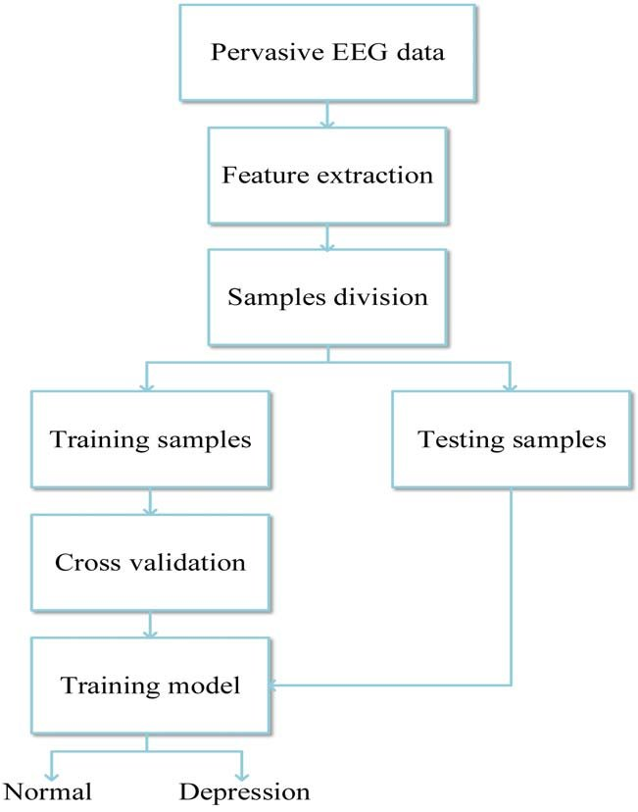

* 1. **Solution Architecture**

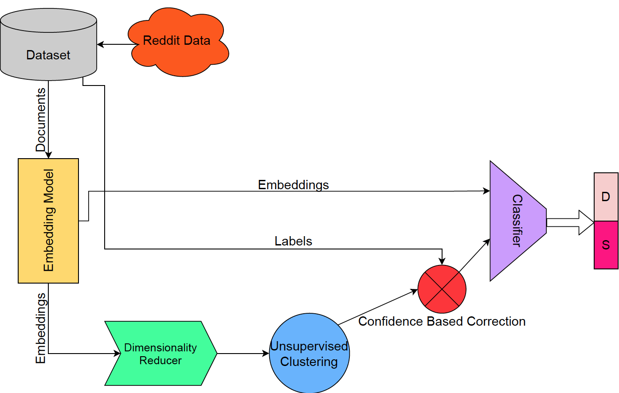

# PROJECT PLANNING & SCHEDULING

* 1. **Technical Architecture**

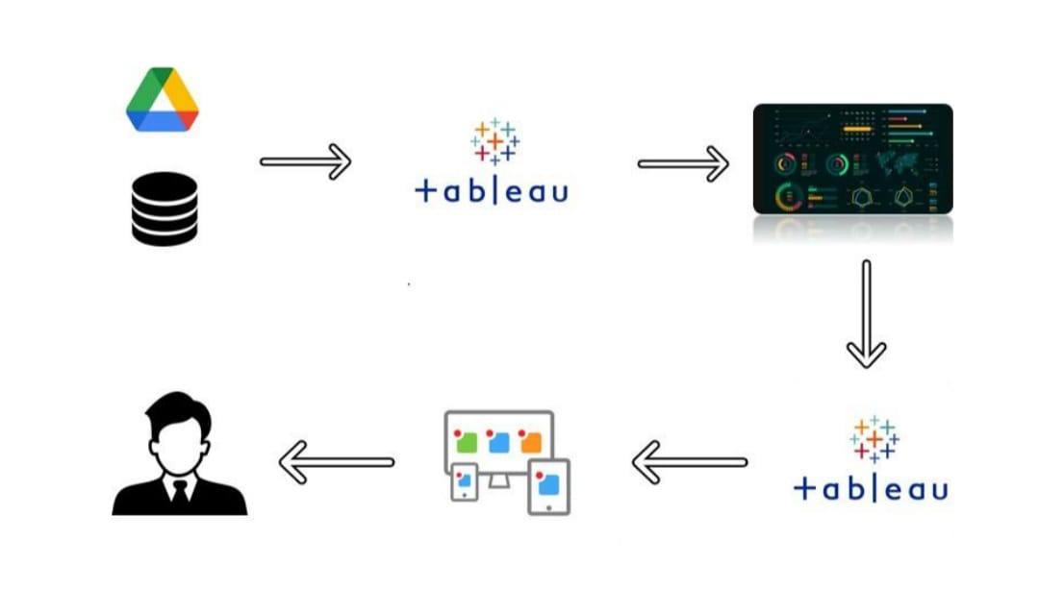

* 1. **Sprint Planning & Estimation**

To manage the development of the project effectively, we will use Agile methodologies with a focus on sprint planning and estimation. Sprint planning will involve breaking down the project into manageable components and defining the scope of work for each sprint. Sprint estimations will be done in story points or time estimates, depending on the nature of the task. The tasks and features to be developed may include:

* Content creation: Developing articles, videos, and other resources about depression.
* User registration and authentication.
* Designing the user interface for the website and mobile app.
* Implementing chat or support features for users.
* Developing a database for storing and managing content.
* Testing and quality assurance to ensure a bug-free experience.
  1. **Sprint Delivery Schedule**

The sprint delivery schedule for the project "Depression: A Common Mental Disorder" will be iterative, with each sprint typically lasting 2 to 4 weeks. The following is a high-level overview of the initial sprints:

Sprint 1: Project Kick-off & Planning

* Define project scope and objectives.
* Develop a high-level project plan.
* Set up development environments.

Sprint 2: User Authentication & Database

* Implement user registration and login functionality.
* Develop the database structure for storing content.

Sprint 3: Content Creation

* Create educational content about depression.
* Populate the platform with initial resources.

Sprint 4: UI/UX Design & Support Features

* Design the user interface for the website and mobile app.
* Begin implementing chat or support features for users.

Sprint 5: Testing & Quality Assurance

* Test the platform for usability and functionality.
* Address any identified issues and improve user experience.

Sprint 6: User Feedback & Improvements

1. **PROJECT DEVELOPMENT PHASE**

1.Download the dataset

2.Store Data in DB & Perform SQL Operations.

3.Connect DB with Tableau

4.Prepare the Data for Visualization

5.Use Tableau to prepare visualizations, dashboard and story.

6.Web Integration(prepare website using bootstrap template)

1. **SQL Queries:**

/****** Script for SelectTopNRows command from SSMS ******/

SELECT TOP 1000 [index]

,[Entity]

,[Code]

,[Year]

,[Schizophrenia (%)]

,[Bipolar disorder (%)]

,[Eating disorders (%)]

,[Anxiety disorders (%)]

,[Drug use disorders (%)]

,[Depression (%)]

,[Alcohol use disorders (%)]

FROM [mentahealth_data].[dbo].[Db_mentalhealth]

--select all the columns

Select * FROM [mentahealth_data].[dbo].[Db_mentalhealth];

--select distinct columns

Select Entity,Code FROM [mentahealth_data].[dbo].[Db_mentalhealth];

--SELECT THE COUNT OF DISTINCT(different coutries)

SELECT COUNT(DISTINCT Entity) FROM [mentahealth_data].[dbo].[Db_mentalhealth];

--SELECT WHERE

SELECT * FROM [mentahealth_data].[dbo].[Db_mentalhealth] WHERE [Depression (%)] >= 6.000000;

---------

SELECT * FROM [mentahealth_data].[dbo].[Db_mentalhealth] WHERE [Bipolar disorder (%)] BETWEEN 1 AND 2 ;

--Order BY(sort the result set)

SELECT * FROM [mentahealth_data].[dbo].[Db_mentalhealth] ORDER BY [Bipolar disorder (%)],[Schizophrenia (%)],[Eating disorders (%)],[Drug use disorders (%)],[Anxiety disorders (%)];

--ORDER BY DESC

SELECT * FROM [mentahealth_data].[dbo].[Db_mentalhealth] ORDER BY [Bipolar disorder (%)] DESC;

-----AVERAGE OF BIPOLAR DISORDER

SELECT AVG([Bipolar disorder (%)]) FROM [mentahealth_data].[dbo].[Db_mentalhealth];

----AVERAGE OF DEPRESSION

SELECT AVG([Depression (%)]) FROM [mentahealth_data].[dbo].[Db_mentalhealth];

--MIN AND MAX QUERY

SELECT MIN([Drug use disorders (%)]),MAX([Anxiety disorders (%)]) FROM [mentahealth_data].[dbo].[Db_mentalhealth];

# PERFORMANCE TESTING

**Model Performance Testing:**

|  |  |  |
| --- | --- | --- |
| **S.No.** | **Parameter** | **Screenshot / Values** |
|  | Dashboard design |  |
|  | Data Responsiveness | It shows the data of Lithuania when we place cursor on it. |
| 3. | Utilization of Data Filters | In first viz:    The data is filtered in ascending manner.  Filtering in data visualization is essential for tailoring data displays to specific user needs, enabling data exploration, improving clarity, enhancing interactivity, and supporting data analysis and decision-making. It is a fundamental tool for turning raw data into actionable insights. |
| 4. | Effective User Story | These interconnected data points paint a vivid picture of alcohol consumption, mental health disorders, and their trends over time, empowering users with a comprehensive understanding of these critical health indicators worldwide.   * The data visualization reveals that Belarus and Russia stand out as the top countries when it comes to alcohol consumption, showcasing the highest rates among all nations. * The visualization provides compelling evidence of a significant increase in alcohol usage over a 27-year period, from 1990 to 2017, indicating a noteworthy trend in global alcohol consumption. * It illustrates the countries with the highest prevalence of anxiety disorders, and prominently ranks New Zealand at the top, offering a clear perspective on the prevalence of this mental health condition in different parts of the world. * A carefully curated list is presented, highlighting the top 10 countries worldwide with the highest rates of bipolar disorder. This list allows for a quick and informative comparison of bipolar disorder prevalence on a global scale. * In addition, a pie chart is included in the visualization, effectively displaying the distribution of countries based on their rates of depression. This chart allows users to grasp the global landscape of depression prevalence. * The visualization concludes by offering a comprehensive overview of schizophrenia rates in every country across the globe. This data provides valuable insights into the prevalence of schizophrenia and its global distribution. |
| 5. | Descriptive Reports | No of Visulizations: 9  No. of stories: 6  No. of dashboards: 1 |

# RESULTS

# 

# 

# 

# 

# ADVANTAGES & DISADVANTAGES

# Advantages:

# This project can lead to increased awareness, reducing stigma, and better understanding of this widespread issue. It can inform evidence-based treatment approaches, support systems, and prevention strategies, ultimately improving mental health outcomes. Additionally, it can foster collaboration between healthcare professionals, researchers, and policymakers, leading to more effective interventions.

# Disadvantages:

# Challenges include ethical considerations in handling sensitive mental health data, potential triggering of distressing emotions in participants, and difficulties in obtaining comprehensive and accurate data due to the stigma associated with depression. There may also be limitations in generalizing findings to diverse populations, and the project's impact may depend on the implementation of its recommendations, which can be influenced by various external factors.

1. **CONCLUSION**

In conclusion, the project on "Depression: A Common Mental Disorder" underscores the pressing need for increased awareness, early diagnosis, and improved access to mental health services. It highlights the complex interplay of factors contributing to depression and offers insights into potential preventive measures and treatment strategies. By addressing these challenges, we can work toward reducing the burden of depression and enhancing the well-being of individuals and society.

# FUTURE SCOPE

# Advanced Interventions: Developing and implementing innovative treatment methods, including telemedicine, AI-driven therapy, and personalized treatment plans.

# Preventive Measures: Exploring new avenues for preventing depression, such as early intervention programs and mental health education in schools and workplaces.

# Data Analytics: Utilizing advanced data analytics and machine learning for early detection and personalized treatment strategies.

# Mental Health Advocacy: Expanding mental health awareness and reducing stigma through advocacy campaigns.

# Global Mental Health: Addressing depression as a global health concern, especially in underserved regions.

1. **APPENDIX**

GitHub & Project Demo Link